Self-help sheet for – Stress
Stress can affect both your emotional and physical wellbeing and can be triggered by any situation that makes you feel overwhelmed or an accumulation of lots of smaller stressors.
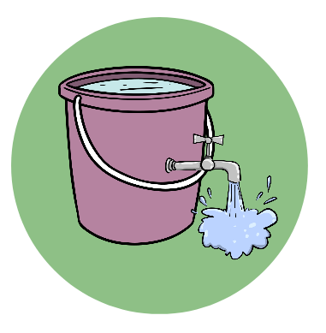
Stress Bucket
Imagine your worries or stressor are like water in a bucket and the bucket being you. So how do we make sure the bucket doesn’t overflow? We need to put a slow flowing tap to release some water so that we can still allow more water to enter the bucket. What could you do to release some water from your bucket?

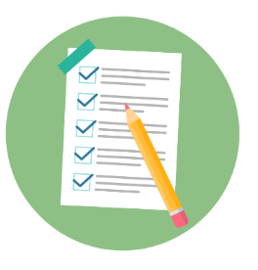
Prioritise:
If you have lots of different tasks to do at once it can start to feel overwhelming. It can be useful to prioritise these tasks to take the load off and feel more in control of your situation. Try writing a list of your tasks, from most important to least important to help you identify which tasks to tackle first and which ones can wait.
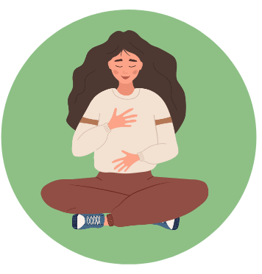

Breathing techniques:
Breathing techniques can be used to help manage the physical symptoms of anxiety and help you to feel calmer.
Blue/cold air vs red/hot air: Breathe in through your nose and imagine breathing in blue, cold, calming air and then breathe out through your mouth, imagining red, hot air releasing your worries and tension.

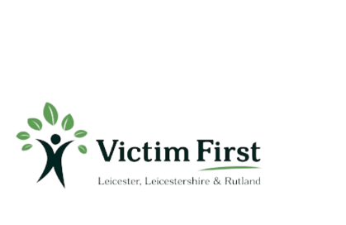
5-3-5 technique: Breathe in through your nose for 5 seconds, hold for 3 seconds and breathe out through your mouth for 5 seconds and repeat until you feel calm.
Belly breath: Often when you feel anxious, you feel rapid breaths in your chest. To counteract this, take long deep breaths whilst placing your hand on your belly and feel the breath expanding in your belly.

Remember, A problem shared is a problem halved. Reach out for support if things feel too much!

