Self-help sheet – Self-Esteem
When our self-esteem is low, we tend to have a more negative outlook on life as we see ourselves and our lives in a more negative light. When we have healthier self-esteem, we tend to feel more positive about ourselves and are able to better deal with life’s ups and downs.

Positive Affirmations
Stand in front of a mirror and repeat positive affirmations about yourself that you wish to be true. This can help to reinforce what you want to believe about yourself and increase confidence. Focus on attributes you would like to see more of in yourself and repeat these back to yourself daily whilst looking in the mirror, eventually your brain will start to believe and act in a way that supports these strengths. For example, tell yourself, ‘I am confident’, ‘I am good at what I do’, ‘I am loved’, ‘I am in control’

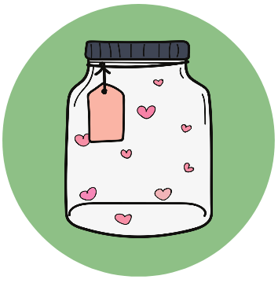 | Positive Reflections Jar  Create a positive reflections jar or list by writing down some positive reflections about yourself. These could include times you have felt proud of yourself, things you like about yourself, or you could add to the jar when you do something well or when someone pays you a compliment. Keep adding different examples to the jar and when you are feeling negative about yourself, look through the jar to remind yourself of all the positive evidence that you are amazing!
Self-Esteem Journal
Use a journal to reflect on what has gone well in your day and what you are grateful for to help avoid focussing on negatives. Consider all of the small wins you have achieved that day, for example, ‘I managed to get up and have breakfast today’. You could also try starting each day by asking yourself what you are grateful for, what you are excited about and who can you ‘surprise’ or do something nice for that day. Focusing on what good can come from the day ahead may help you to feel more positive about yourself.
Set small goals
Set yourself small goals relating to your confidence and self-esteem. For example, ‘In two weeks, I will be able to say 3 good things about myself’.
Then, once you have achieved this goal, set yourself new goals to take another step towards your end goal. For example, your next goal could be ‘in 3 weeks I will be able to tell one other person one positive thing I like about myself’ Continue to set yourself these small goals until you reach your end goal.

Remember, A problem shared is a problem halved. Reach out for support if things feel too much!

