Self-help sheet – Low Mood
Low mood can affect anyone and affect people in different ways. Feeling low is common after distressing events or major life changes, but sometimes periods of low mood happen for no obvious reason. The good news is that there are things you can do to improve your mood.
Relaxation techniques
Try some mindfulness techniques to help you relax. For example, Imagine you are sat by a stream and every time a painful thought comes into your mind, imagine it on a leaf floating away from you down the stream. Or imagine your thoughts as bubbles, watch them float up into the air until they pop or float out of sight.

Worry Journal
When your worries feel overwhelming, releasing them from your mind can help. If you don’t feel up to speaking to someone, sometimes writing these down can be enough. Grab your favourite notebook/ journal and write down what your thoughts and feelings are, if you can’t put these into words try drawing how you feel as another way to express how you feel.

Self-Care
Exercise: Doing physical activity can help release positive endorphins that boost your mood. Whether this is doing a small home workout, going for a walk in nature or heading to the gym, try your favourite activity to boost your mood.
Get creative: Try something new. For example, painting, cooking or crafts.
Treat yourself: do something that makes you feel good like having a bubble bath, taking yourself out for lunch or treating yourself to a haircut or something new.
Set small goals
Sometimes low mood can affect motivation, so setting small goals can help bring routine into your life and recognise the small wins. For example, using a to-do-list to set yourself a time to make yourself breakfast.
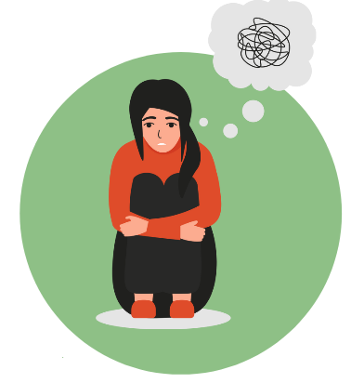 | Challenge unhelpful thoughts  Identify what your thoughts are and where they have come from and challenge whether they are rational thoughts. For example, ‘I am no good at anything’, you can challenge this by writing down things you are good at or asking others what you are good at. Also consider whether the negative thought is within your control and focus on what actions you can take to make the situation better.
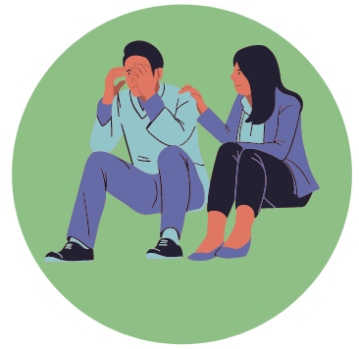 | Reach out  Sometimes it can help to speak to others about how we are feeling, try calling a friend or family member or speaking with a medical professional about how you are feeling. You can also reach out to crisis helplines such as Samaritans.
Remember, A problem shared is a problem halved. Reach out for support if things feel too much!

