Self-help sheet – Anxiety
Feeling tense, stressed, and worried at certain times when under pressure is a normal human response. Everybody feels anxious from time to time. Anxiety becomes a problem when it is intense and prolonged, and when it starts to get in the way of day-to-day functioning. Below you can find some helpful coping techniques.

Grounding Techniques
Grounding techniques can be used when you feel overwhelmed. They help you to feel present in the current moment, act as a reminder that you are in control and take your mind off your worries.
54321 technique: Identify 5 things you can see around you, 4 things you can hear, 3 things you can touch, 2 things you can smell and 1 thing you can taste.
Journey of an object: Focus on an object you can see and imagine the journey it’s been on eg. how a table came from being a tree to being a table in front of you.
Sensory object: Hold an object in your hand and describe how it feels. For example, is it hard? How many sides has it got? How heavy is it?
Favourites: list your favourite food, colour or film or imagine your favourite place or someone that makes you happy, imagine their face, smell, voice etc

Worry Journal
When your worries feel overwhelming, releasing them from your mind can help. If you don’t feel up to speaking to someone, sometimes writing these down can be enough. Grab your favourite notebook/ journal and write down what your thoughts and feelings are, if you can’t put these into words try drawing how you feel as another way to express how you feel.
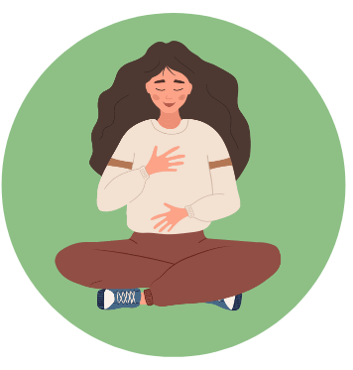 | Breathing Techniques  Breathing techniques can be used to help manage the physical symptoms of anxiety and help you to feel calmer.  Blue/cold air vs red/hot air: Breathe in through your nose and imagine breathing in blue, cold, calming air and then breathe out through your mouth, imagining red, hot air releasing your worries and tension.  5-3-5 technique: Breathe in through your nose for 5 seconds, hold for 3 seconds and breathe out through your mouth for 5 seconds - repeat until you feel calm.  Belly breath: Often when you feel anxious, you feel rapid breaths in your chest. To counteract this, take long deep breaths whilst placing your hand on your belly and feel the breath expanding in your belly.
Relaxation
Try a mindfulness technique to help you relax. For example, imagine you are sat by a stream and every time a painful thought comes into your mind, imagine it on a leaf, floating away from you down the stream. Or imagine your thoughts as bubbles, watch them float up into the air and pop as they disappear.

Remember, A problem shared is a problem halved. Reach out for support if things feel too much!

